Estrutura de Dados

Aluno: Luiz Gustavo de Miranda Genuino

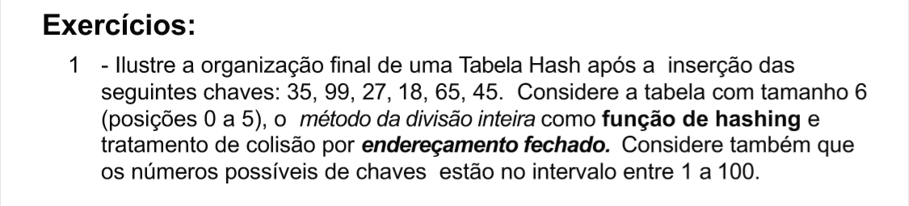

|  |
| --- |
| índice |
| 0 |
| 1 |
| 2 |
| 3 |
| 4 |
| 5 |

18

45

27

99

65

35

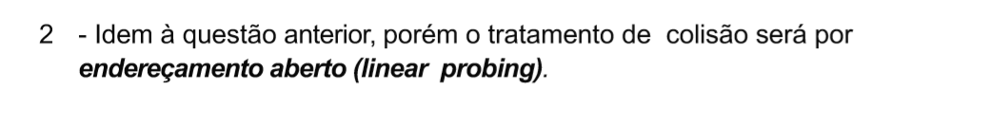

|  |  |  |  |  |  |  |  |  |  |  |  |
| --- | --- | --- | --- | --- | --- | --- | --- | --- | --- | --- | --- |
| 0 | 1 | 2 | 3 | 4 | 5 | 6 | 7 | 8 | 9 | 10 | 11 |
| 18 |  |  | 99 | 27 | 35 | 65 | 45 |  |  |  |  |

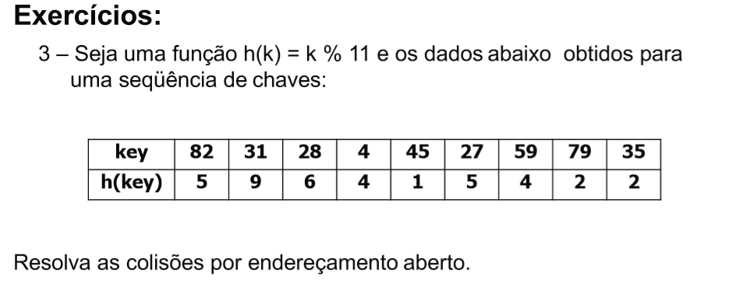

|  |  |  |  |  |  |  |  |  |  |  |
| --- | --- | --- | --- | --- | --- | --- | --- | --- | --- | --- |
| 0 | 1 | 2 | 3 | 4 | 5 | 6 | 7 | 8 | 9 | 10 |
|  | 45 | 79 | 35 | 4 | 82 | 28 | 27 | 59 | 31 |  |

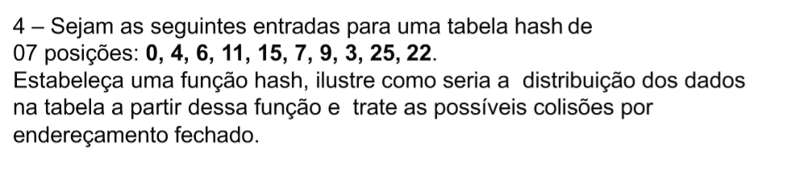

Função: h(k) = k % 7

22

25

3

9

15

0

7

4

11

6

|  |
| --- |
| 0 |
| 1 |
| 2 |
| 3 |
| 4 |
| 5 |
| 6 |

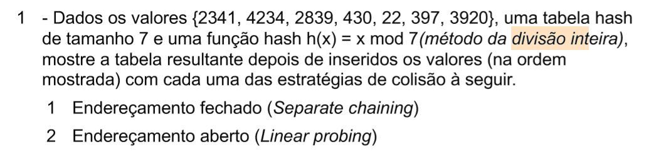

1

4234

430

2839

430

2341

22

3920

|  |
| --- |
| 0 |
| 1 |
| 2 |
| 3 |
| 4 |
| 5 |
| 6 |

2

|  |  |  |  |  |  |  |
| --- | --- | --- | --- | --- | --- | --- |
| 0 | 1 | 2 | 3 | 4 | 5 | 6 |
| 397 | 22 | 3920 | 2341 | 2839 | 430 | 4234 |

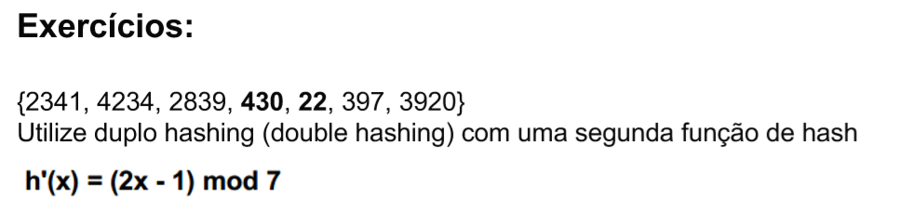

|  |  |  |  |  |  |  |
| --- | --- | --- | --- | --- | --- | --- |
| 0 | 1 | 2 | 3 | 4 | 5 | 6 |
| 3920 | 430 | 22 | 2341 | 2839 | 397 | 3234 |

**EXERCÍCIOS DE TEORIA DOS GRAFO**

1 - O que é um Grafo?

Grafos são representações de conjuntos de conexões entre pares de objetos ilustrados através de vértices que representa os objetos simples que podem atributos como nome, e as arestas que fazem as conexões entre os vértices.

2 - Desenhe a representação gráfica das matrizes de adjacências dos grafos a seguir:

